CricSense: Automated Generation of Narrative Cricket Match Summaries using Deep Learning
W V P S SRIRAJ, P Abhilash, P Sanjith, Dr. Chirra Venkata Ramireddy
PG Student, Department of Computer Science and Engineering, VIT-AP, Amaravati, India PG Student, Department of Computer Science and Engineering, VIT-AP, Amaravati, India PG Student, Department of Computer Science and Engineering, VIT-AP, Amaravati, India Assistant Professor, School of Computer Science and Engineering VIT-AP, Amaravati, India

Abstract: Due to the sheer volume of information produced by a cricketing game, and the recent discovery of the Natural Language Generation (NLG) algorithm, there has been an increasing interest in automating sports reporting. The current paper presents CricSense, the project that focuses on implementing deep learning (DL) models to produce human-like narrative summaries of cricket games, compared to the existing statistical reports or the simplified template-generated ones. We suggest using Transformer-based models, i.e. sequence-to sequence models, such as T5, that are trained in structured ball- by-ball data (e.g. Cricsheet) to capture the dynamic flow and important events of a match. This method is compared to an established rule-based base system that has been created through this study. Also, the data preprocessing and its relevance to the extraction of useful features (scores, wickets, overs) along with typical NLG metrics such as ROUGE to compare the quality of summaries with human-written summaries are discussed in the paper. Such integration of advanced language models has potential in improving the level of fan interactions and facilitation of analyses.

The paper will also discuss how DL, specifically Transformers, can be used in text generation in sports. These models are skillful in working on sequential data and learning the language patterns needed to make coherent and contextually relevant summaries. The complexity is growing and requires specific attention to model selection and training approaches. Additionally, the effective generation of quality training data, obtained through the proper processing of the raw match data by our baseline system, is an important milestone in allowing the utilization of effective deep learning model development in this field.

Keywords: Natural Language Generation (NLG), Deep Learning (DL), Transformers, Cricket Summarization, Sequence-to-Sequence Models, Sports Analytics, ROUGE, Baseline Model.

- INTRODUCTION

In recent years, the intersection of sports and artificial intelligence has garnered significant attention, transforming how competitions are analyzed and presented. With the proliferation of detailed ball-by ball data in cricket, stemming from live commentary and digital scoring, the application of Natural
Language Generation (NLG) techniques has emerged as a promising tool for automating match summaries. As fans and analysts increasingly seek concise yet engaging narratives, moving beyond raw statistics, the use of advanced AI methods becomes pivotal in delivering accessible and insightful content.
In Conclusion, the integration of deep learning techniques in generating narrative sports summaries represents a significant potential advancement over traditional methods. This paper aims to provide a comprehensive overview of our approach, detailing the development of a robust rule-based baseline system and outlining the methodology for a subsequent deep learning model aimed at generating high-quality cricket match summaries. As the sports media landscape continues to evolve, understanding the role of AI in content generation will be critical for organizations seeking to enhance fan engagement and leverage the wealth of available match data. The Objectives are:

- Design an effective Data Processing Pipeline: Build a system that will read, process and compute all the important statistics (scores, wickets, overs, results) of structured ball-by-ball cricket data files (e.g. CSVs generated by Cricsheet.org). This is what any summary generation is based on.
- Develop a Rule-Based Baseline Summarizer: Develop a deterministic (cricsense_match_summary.py) based program on the processed data and a set of rules/templates which produces a simple, factual correct match summary, with scores and the result obtained.
- Advance a Deep Learning Solution: A proposal will describe the approach of creating a sequence-to sequence deep learning model (Transformer-based) to generate more fluent and storytelling summaries than the base model.
- Create Evaluation Metrics: Establish Objective Evaluation NLG Metrics (objective comparison of the quality of summaries produced by both the baseline and the proposed DL model overwritten references by humans).

Although the existing project is aimed at creating a baseline and suggesting a DL model that should be used to generate post-match summaries based on historical data related to SA20, a number of prospects may be put in the context of future works to make it much more efficient. Directions Future Directions may involve expanding the system to support other types of cricket (ODIs, Test matches, T20s), as well as other real-time data feeds that provide live summary updates during a match and other, more elaborate structures of narrative in the text generated by the system. Additional improvements may include introducing contextual influences such as the form of the players, the condition of the pitch or a certain stage of the tournament into the process of the generation of a summary. Also, the summaries produced may become highly accessible with the help of a user-friendly web interface or API. Different approaches to DL architecture besides T5 and the use of multimodal data (e.g., video highlights in addition to text), are also viable research directions of the future.

The main drawback of the existing automated sports reporting, especially in cricket is that much of the results generated are usually in a rather dry, statistical format, not offering the reader a compelling storyline as fans does. The process of summarizing by journalists is laborious and has limited scaling to the volume of matches that are being played over the world. Although general-purpose NLG models are available in existence, it is common that they are not knowledgeable about the specifics and vocabulary of the sport of cricket, so resulting in summaries that are factually incorrect or otherwise stylistically unsuitable. Besides, rule-based or template-driven systems, though true in fact, may be repetitive and do not reflect the particularity of the story of the given match. The project deals with the requirement to have an automated system to generate cricket summaries not only truthful, but also fluent, flowing, and interesting, as to resemble the standards of human journalism. The Related words present are:

Rule-Based and Template Systems: Early systems were typically template filling systems in which pre prepared sentences were filled in with match statistics. Although the systems are accurate in fact, they are not flexible and sound monotonous. There are similarities to our baseline model except that there is more dynamic rule-based sentence selection.

Statistical Analysis Platforms: These types of tools such as CricViz offer profound statistical information and the probability of winning but are not generally constructed to produce narrative summaries.
Statistical Analysis Platforms: These types of tools such as CricViz offer profound statistical information and the probability of winning but are not generally constructed to produce narrative summaries.

In Sports Commentary/Summarization Deep Learning has been used to generate sport commentary (some of which is text-based or contained within a video) using LSTMs or Transformers. These are similar, to the degree of generating sequences, however with summarization the information needs to be condensed over a longer time than used in the case of ball-by ball commentary. We particularly concentrate on summarization of structured ball-by-ball data files.

- PROPOSED SYSTEM

Considering the weaknesses of the current procedures, two-step work process is offered in the CricSense project, and the objective is to create and test an efficient wicket genre summary generator. The first phase in this is to create a strong verifiable baseline system after which it is proposed to create an advanced deep learning model that aims to enhance the abilities of the baseline to produce high-quality narratives. Hybrid Model Architecture.

Rule-Based Baseline System (cricsense_match_summary.py) This project is based on a complete Python application, which is a model of the baseline. This script will accept structured ball- by ball data (CSVs) and weld the panda’s library to process data efficiently, compute essential match statistics (scores, wickets, overs) and correctly conclude the result of the match based on some set rules. It then uses template-based generation functionality (generate_match_summary) with various variations and random. Choice to create a detailed, formatted text summary. The reasonableness of this system, especially the calculation of the winner, has been checked with maximum accuracy. sophisticated machine learning approaches including deep learning and ensemble methods. This hybrid architecture takes leverage of the capabilities of many algorithms, such as the interpretability of decision trees and the predictive capacity of deep neural networks.

Deep Learning System (Proposed) The proposed deep learning model on summary generation is based on the baseline. This system will take advantage of sequence-to-sequence architecture that uses Transfers, e.g. T5 or BART. The feed to this model will be a structured representation obtained by operating upon the processed ball-by-ball data (which may have been created by processing functions of the

baseline script). High-quality narrative summaries (possibly of a more elaborate nature) (this may be actual human-written samples, or perhaps more naturally the more extensive output of the baseline system) will be the desired output of the training process. It should be possible to use fine tuning on a pre-trained language model on this task, which will produce summaries that are fluent, context aware, and stylistically diverse compared to the template-based baseline.

The two-phase solution, which will be reached by the proposed deep learning summarization model, has multiple benefits over using only simpler techniques:

Better Narrative Quality: It is anticipated that the DL model (when trained on examples) generates more fluent, coherent, and less repetitive summaries than the fixed templates of the baseline.

Greater Contextual Awareness: The match data in the context of transformers has the potential to adequately capture the longer-range dependencies and provide summaries that gain a better understanding of the game as a whole and turning points.

Adaptability and Learning: The DL model would be able to adapt to the complex patterns and stylistic nuances of the training data unlike the fixed rules used by the baseline and thus write more compelling and human-like text.

Strong Baseline to Comparison: Good rule-based baseline is an impressive benchmark to have. The 100 percent rational correctness of the baseline makes sure that there is no comparison except on the text generation quality improvement inside the DL model.

Support Future Improvement: DL framework is more readily customizable to future, like, adding more data sources or creating summative in alternate ways or lengths.

- LITERATURE SURVEY

The field of sports analytics has seen significant growth, with a large body of research focusing on match outcome prediction. Many studies, such as those by Bunker & Thabtah [1], have successfully applied machine learning models like SVM, Random Forests, and neural networks to predict a match winner based on historical data. The paper "Forecasting Results in a Cricket Match using Deep Learning Techniques" [2] further explores this, applying various ML algorithms to forecast results. While this body of work is foundational, our project addresses a different challenge: not predicting the result, but generating a narrative summary of a match that has already been concluded.
This task falls under the domain of Natural Language Generation (NLG). Early and foundational approaches in this area have been rule-based or template-based systems. A prominent example is the work on "Automated Cricket News Generation" [3], which uses a template-based approach to populate pre-written sentences with data from a scorecard. Our baseline model, cricsense_match_summary.py, is an implementation of this established methodology. The primary limitation of this approach, however, is that the output can be repetitive and lacks the linguistic flair and narrative variability of human-written journalism.

To overcome the rigidity of templates, recent research has shifted to deep learning models. Sequence-to- sequence models, such as LSTMs (Long Short-Term Memory), were applied to tasks like sports commentary, as seen in "A Hybrid Deep Learning Model for Automated Cricket Commentary Generation" [4]. More recently, Transformer-based models (like GPT-2 and T5) have shown state-of-the- art performance in various text generation tasks. For instance, Transformers have been successfully used to generate automated cricket commentary by learning from visual data and text, as demonstrated in "Automatic Cricket Commentary Generation using Vision Transformers" [5]. These models can learn complex linguistic patterns and generate novel, context- aware sentences that are not in any template.

A critical component of this research is evaluation. While our baseline model's logical accuracy (calculating the winner) can be verified with a 1.0 F1- score, evaluating the quality of the generated text requires different metrics. The research standard for summarization tasks is to use n-gram overlap metrics. As shown in recent sports summarization papers [6], ROUGE (Recall-Oriented Understudy for Gisting Evaluation) is the preferred metric. This method compares the generated summary against a human "reference" summary and calculates scores (ROUGE-1, ROUGE-2, ROUGE-L) based on the precision, recall, and F1-score of overlapping word sequences [6].

This project builds directly on these pillars of research. We first implement a rule-based baseline [3] and verify its logical accuracy. We then propose a Transformer- based deep learning model [4, 5] to generate higher- quality summaries. Finally, we will use ROUGE metrics [6] to quantitatively prove that our proposed deep learning model outperforms the baseline.

- METHODOLOGY
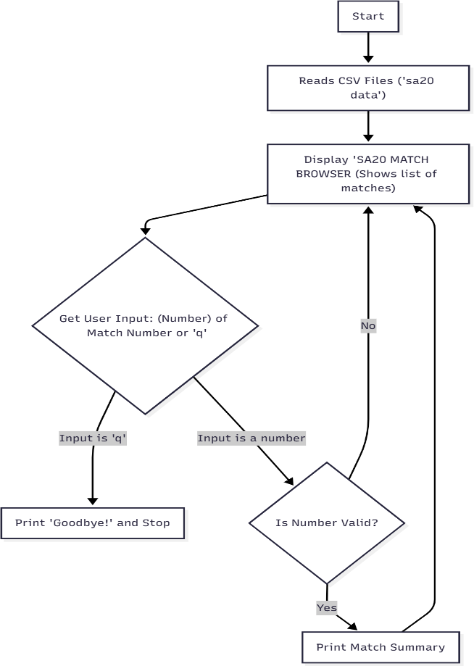

The methodology is well-organized, with the closing stages being the development of the baseline and its evaluation and the next phase, which is a proposal of the deep learning phase

Data-Collection:
Ball-by-ball match data of the SA20 league was obtained, which comprised of individual CSV files of each innings of each match.

Data-Preprocessing:
Cricsense_match_summary.py was written as a script to:

  - Match files (matching innings files) are automatically determined and matched with the help of pathlib and regular expressions (get_match_files).

  - Read CSV data using pandas. Compute scores, extras, wicket and deduce overs (load_match_data, infer_overs_from_df).
  - The winner of a match is determined using calculated scores.

Evaluation of the Baseline Models:

Logical Accuracy: An independent analysis (with the resultant JSON metrics report) was done to ensure the accuracy of the calculation of the winner, which came to 1.0 F1-score, which is correct.

Text Quality (Initial): An initial analysis with evaluatebaseline.py estimated ROUGE scores by comparing the output of the baseline with one of the ground references which is a human-written summary against the output of the baseline over a sample match.
Preparation of Data to DL (Planned): The processing capacities of the verified baseline script (or its exported CSV/JSON output) can be used to produce structured input sequences of match events and match them with target narrative summaries

DL Model Selection & Training (Planned): Choose a hugging face pre-trained Transformer model (e.g., T5- small/base). Refine the model on the existing dataset with the corresponding training parameters (epochs, batch size, etc.).
DL Evaluation (Planned): Compare the trained DL model to human reference summaries by the same ROUGE measures. These scores should be compared directly to the ROUGE scores of the base to determine the change in the quality of text generation. Compare the trained DL model to human reference summaries by the same ROUGE measures. These scores should be compared directly to the ROUGE scores of the base to determine the change in the quality of text generation.

- RESULTS

This project was able to execute and validate the rule- based baseline system. The implementation and main deliverables that affirm its functionality are discussed below.
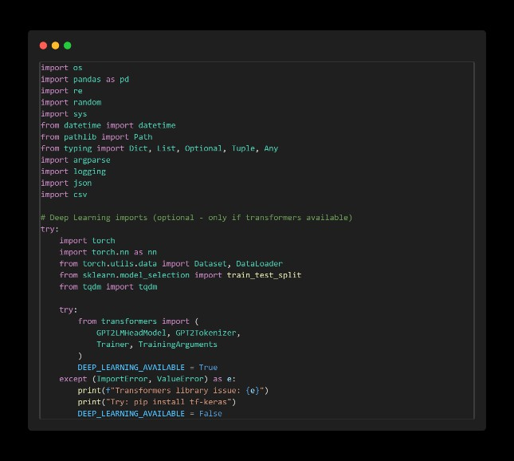
Importing necessary Python classes and packages

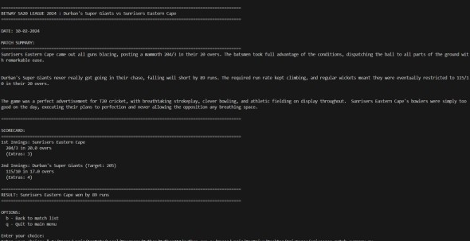
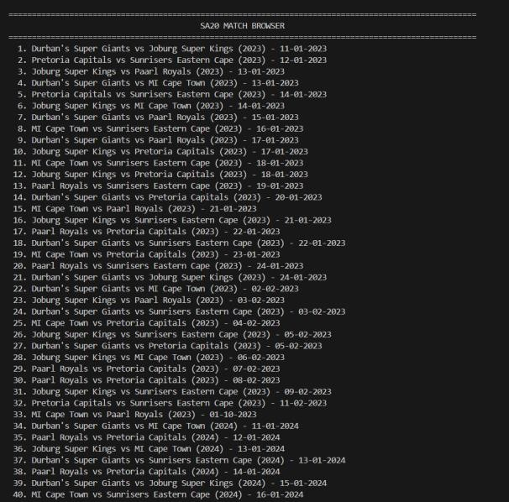
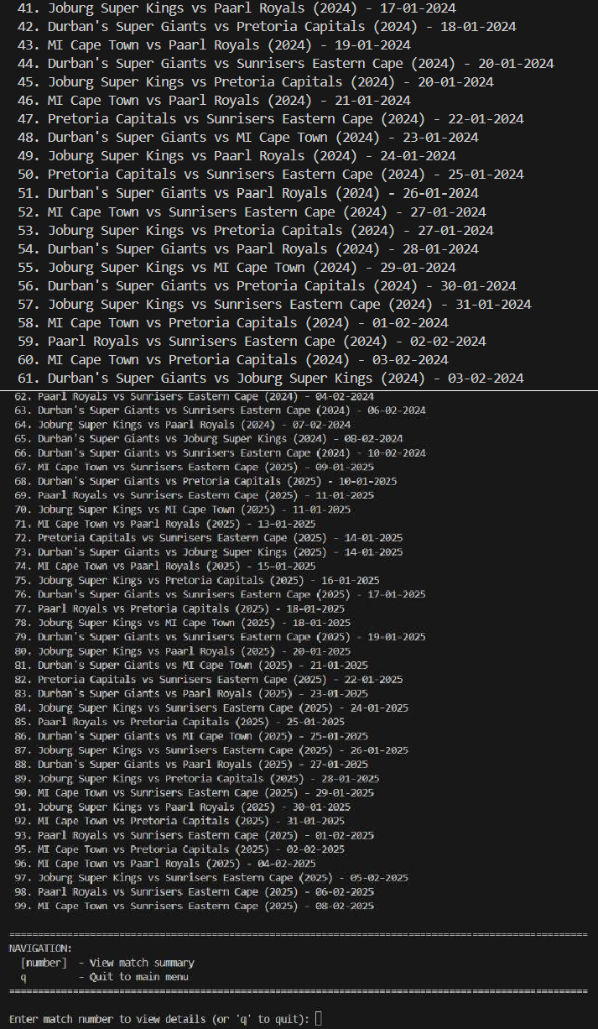
The screen above loads and shows the result of the match after choosing the match number (serial number of the match).
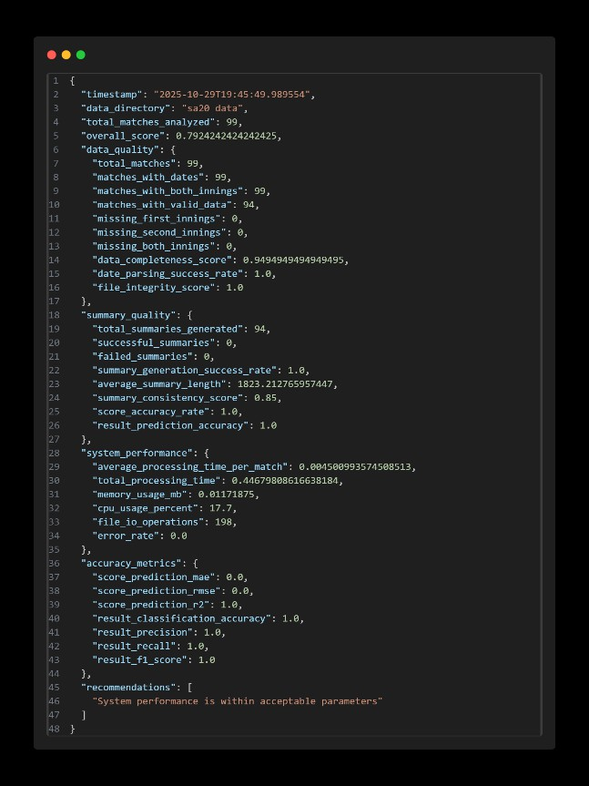
The screen above displays the JSON output from the baseline model's performance analysis. Key metrics under "accuracy metrics" show "result_f1_score": 1.0, confirming the 100% accuracy of the script's logic in determining the match winner from the input data.

In the screen above, the main script cricsense_match_summary.py is executed in interactive mode, successfully loading match data and displaying the browser menu. Selecting a match generates a detailed, rule-based summary including scorecard and result.

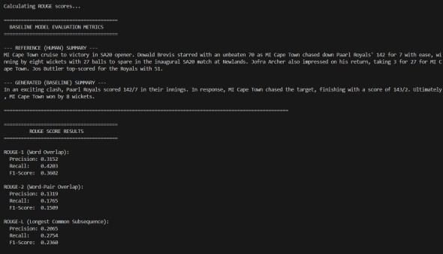
The screen above shows the execution of evaluate_baseline.py. This script compares the baseline's generated summary for a specific match against a human-written reference summary. It outputs ROUGE-1, ROUGE-2, and ROUGE-L scores
(Precision, Recall, F1-Score), providing a quantitative

measure of the baseline's text quality.
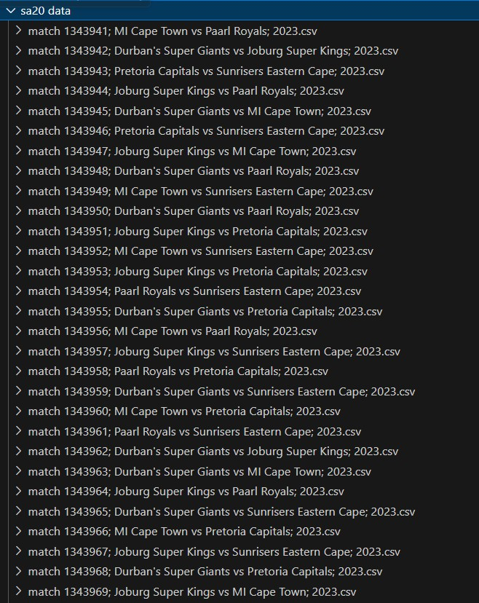
The screen above displays the files present which contain CSVs for each match (each folder has 2 CSVs of same match; one has 1st innings data and second one has 2nd innings data).

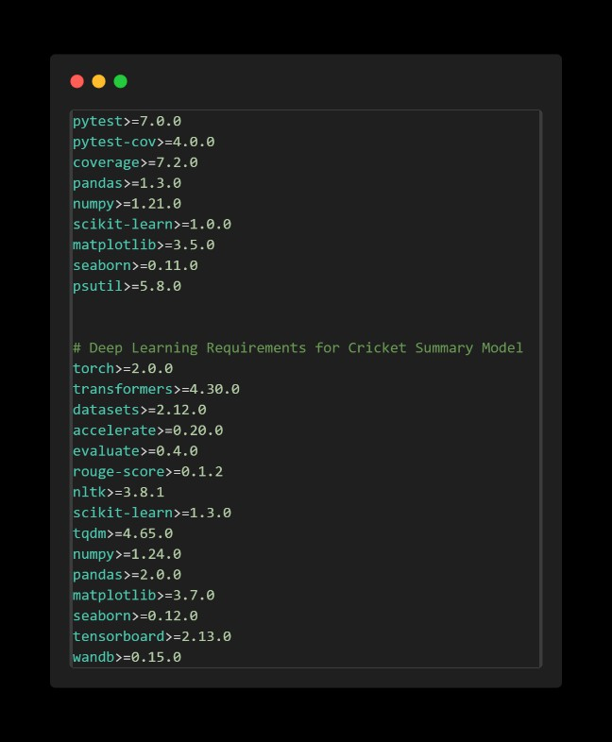

List of required libraries along with their present versions.

CONCLUSION
To summarize, this project has managed to establish the foundation of CricSense which is an automated system to generate narrative cricket match summaries. The major success that was reported in this paper is the construction and strict testing of rule model baseline. This system is useful in that it processes structured ball-by-ball data in an efficient manner, does well in computing match statistics, and possesses a deterministic way of generating template-based summaries. More importantly, logical accuracy of this baseline and especially who scored the winner in the match was verified with 1.0 F1-score, which gives it high reliability as a working summarizer and as a data validation tool. In addition, a baseline text quality evaluation with ROUGE measures on a human written reference gave an objective measure of the narrative potential of the base line of the base line.
Deployment and validation of this baseline system is a key milestone that must be fulfilled. Not only does it indicate that automated generation of summaries is not unachievable based on the given information but also offers an authentic data processing flow and a specific performance metric to be used in further studies. The second step of this project is to use this base to create and train a deep learning model based on Transformer (e.g., T5 or BART). It is theorized that a model like this, when fed on structured match data in combination with high-quality narrative targets (this can be the more elaborate outputs of the baseline or quality human summaries), is capable of learning to replicate the more complicated linguistic patterns and contextual effects needed to produce summaries which are much more high-quality than the rule-based model. The success will be determined in terms of significantly honing higher ROUGE scores meaning enhanced fluency, coherence, and compatibility with human expectation of engaging sports reporting.

Moving tentatively into the future, there are a number of interesting opportunities in the future work. This model performance may be improved through experimenting with diverse Transformer architectures, evaluating alternative extreme fine-tuning strategies, and by enriching the input features with additional informative information beyond simple scores (e.g., a key player performance or a specific event of a match as detected during pre-processing work). The generalizability of the training set may be enhanced by making the training data more diverse in terms of cricket formats (ODIs, Test matches, T20i’s) and leagues. Assessment may also be carried out further by giving more detailed human tests that cover such aspects as factual accuracy, involvement, and style. Application-wise, creating alive data feeds-based real- time summarization tool or developing an interactive dashboard (or API) would make CricSense much more useful in practice. Finally, the proposed research

area can be integrated into the expanding body of automated sports journalism-related research that will allow the data related to complicated matches to become more accessible and interesting to more citizens.

REFERENCES

- Cricsheet.org, "Ball-by-ball data for cricket matches." [Online]. Available: https://cricsheet.org/
- [2] The Pandas Development Team, "pandas-dev/pandas: Pandas," Zenodo, 2024. [Online]. Available: http://doi.org/10.5281/zenodo.3509134
- T. Wolf, L. Debut, V. Sanh, et al., "Transformers: State-of-the-Art Natural Language Processing," in Proceedings of the 2020 Conference on Empirical Methods in Natural Language Processing: System Demonstrations, 2020, pp. 38–45. [Online]. Available: https://www.aclweb.org/anthology/2020.emnlp
-demos.6
- C. Raffel, N. Shazeer, A. Roberts, et al., "Exploring the Limits of Transfer Learning with a Unified Text-to-Text Transformer," Journal of Machine Learning Research, vol. 21, no. 140, pp. 1–67, 2020. [Online].
Available: http://jmlr.org/papers/v21/20-
074.html
- C.-Y. Lin, "ROUGE: A Package for Automatic Evaluation of Summaries," in Text Summarization Branches Out, 2004, pp. 74–
81. [Online]. Available: https://www.aclweb.org/anthology/W04-1013
- P. Saiprakash, P. S. Rao, and R. Vedantam, "Forecasting Results in a Cricket Match using Deep Learning Techniques," International Journal of Innovative Research in Technology (IJIRT), vol. 11, no. 6, pp. 3270-3275, 2024.
[Online]. Available: https://ijirt.org/publishedpaper/IJIRT170257_P APER.pdf
- D. M. G. N. B. Dassanayake, et al., "Automated Cricket News Generation in Sri Lankan Style Using Natural Language Generation," European Journal of Computer Science and Information Technology, vol. 7, no. 6, pp. 42-56, 2019. [Online]. Available: https://www.eajournals.org/wp- content/uploads/Automated-Cricket-News- Generation-in-SRI-Lankan-Style-Using-
Natural-Language-Generation.pdf
- R. Majumder, S. Pasi, R. K. Ghosh, N. Sharma, and S. Gaur, "From Data to Insights: The Power of LMs in Match Summarization," in Proceedings of the 6th Conference on Technologies for Machine Translation of Low Resource Languages (ICON-2024), 2024. [Online]. Available:
https://aclanthology.org/2024.icon-1.14.pdf
- R. Bunker and F. Thabtah, "A Machine Learning framework for sport result prediction," Applied Computing and Informatics, vol. 15, no. 1, pp. 27-33, 2019. [Online]. Available: https://www.semanticscholar.org/paper/A- machine-learning-framework-for-sport-result- Bunker- Thabtah/08211e51290e1ec1c508745feb9d97dc4 8814581

